# PE:

**Art & Design:** As artists, we will be focusing on weaving and creating a final piece that represents our local landscape. We will practice our technique using paper before we move into using natural materials. The children will create a final piece of weaving thinking about how it represents their local environment.

**Design & Technology:** As designers we will be focusing on mechanisms, wheels and axles. We will first look to identify what each component means and where they are located on a simple model of a car. We will design and create a simple vehicle for an alien to move around a planet. We will finish the unit by evaluating our models and considering how we can improve them.

As well-rounded, active citizens, our children will feel a sense of belonging by immersing themselves in a wide range of physical activities. We are beginning this term with gymnastics, and our 2 lessons will take place on Monday and Thursday afternoons.

## Forest School:

We are extremely fortunate to be able to access provision for outdoor learning. We will be heading off on our adventures this term!

## Science:

As Scientists, we will be investigating everyday materials. We will begin by identifying and naming everyday materials and exploring their properties. We will be researching Charles MacIntosh and how he made material waterproof. We will conduct a number of tests throughout this learning and finish by developing a roof suitable for the three little pigs.

## Maths:

As Mathematicians, we will be looking at addition and subtraction to 100, multiplication and division, time and money. Throughout the math’s lessons, we will be applying our knowledge to problems and being able to explain their mathematical knowledge. We will also be having daily number sense sessions.

**RHE:**

As healthy, confident and resilient children, we will be learning about safety and the changing body. Throughout the year our learning will be built upon foundations of understanding our emotions, techniques to help us regulate how we are feeling and mindfulness.

**Computing:**

In computing we will be developing our understanding of technology and how it can help us. We will become more familiar with programming and using our bee bots to program a moving robot.

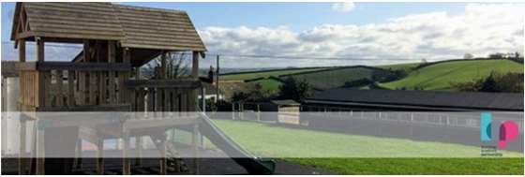

**Hazel Class Year 1 & 2**

**Spring Term 24-25**

**RE:**

This half term the children will begin by exploring the question ‘Who is Muslim’; thinking about how they live and celebrate whilst learning some of the key Muslim stories.

**Christian Distinctiveness:**

We demonstrate our Christian Values through daily acts of collective worship, singing worship and family group acts of worship.

## English:

During the Spring term, our daily English session will be made up of Read Write Inc and handwriting. These sessions are really about embedding and applying the children’s decoding skills, so reading becomes second nature. We will also spend more time focusing on developing their comprehensions skills so they can talk about what they have read with confidence and also retrieve answers from the text they have read.

During their RWInc sessions the children also have the opportunity to build up their stamina for writing.

## History and Geography:

As geographers, will be thinking about hot and cold countries around the world. Throughout this learning we will be learning the 7 continents and the 5 oceans. We will then use this knowledge to identify the location of hot and cold countries in relation to the equator.

**Music:**

As musicians, we will be listening to and appraising a range of different music and songs focusing on our imagination. We will be finding the beat in a range of music, recognising the instruments we can hear and discussing the inspiration for the music. During our lessons we will also start to improvise and create our own melodies and rhythms using a variety of instruments.

As historians, we will be thinking about Christopher Columbus and Neil Armstrong. We will be using sources to identify why each of these people are significant in our history and the impact they made. We will then draw similarities and differences between the two men.