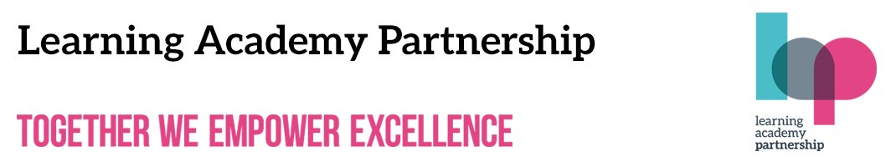   | West Alvington Church of England Academy  25th June 2021

Dear Parents,

COVID-19 current picture
You will be aware of the pause moving to step 4 of the Government’s roadmap out of lockdown. Nationally there are around 8,000 new COVID-19 cases a day, increasing by around 64% a week. Devon cases are increasing too - inevitable with more social contact taking place in the community. Our weekly case rate is 21.7 per 100,000, compared with 12 per 100,000 around ten days ago.

It’s therefore important our school continues to follow national guidance and measures already in place - reducing the risk of transmission and helping protect ourselves, our pupils, families, and friends against the virus.

We ask that you keep going with all your measures - including twice a week lateral flow testing (if possible), handwashing, respiratory hygiene, face coverings where recommended, social distancing The current national guidance from step 3 remains in place, unless there are any Government announcements before 19 July. If your child has a persistent cough, high temperature or loss of taste or smell please get a test.

Sports Day
Following the government announcement that the easing of restrictions in England has now been delayed and the rise in cases locally we have needed to reevaluate some of the events that we were planning to hold. Unfortunately, we will now not be able to invite parents to our Sports Day. However, the teachers are continuing to arrange a wonderful Sports Day experience for our children and they will participate in a day filled with sports and competitive spirit. Within their teams, the children will engage in a range of sporting fun to earn points. As I am sure you will understand, we want the children to be able to come together as a big family for this day and we would like to prioritise this to ensure that they can enjoy this special day on the field together. We have used our risk assessment to plan for all situations and with the volume of parents and children in the school, we would not be able to offer a 'whole school' feel for the children which we believe is really important. We will, of course, ensure that we have lots of pictures and videos on the social media sites for you to enjoy!

Family Support

Do you work in a supermarket or grocery?
School Essentials Grant
Our non-repayable School Essentials Grant is designed to help low income families with the cost of school uniform and equipment for the start of the new school year.
Parents employed in grocery for at least six months can apply to receive £150 per school-aged child (maximum of three children for payment). The School Essentials Grant is a limited fund and it will close when it has been spent.
Follow the link for more information
https://www.groceryaid.org.uk/get-help/school-essentials-grant/

A message from Marcus Rashford!

Dear Parent/Guardian,
We hope you are well and that your child/ren is enjoying the summer term and the warm weather!

Ahead of the summer holidays, we wanted to let you know about the brilliant new Holiday Activities and Food programme which is operating in your local area. We are helping to launch a new film to promote the programme so parents know that their children can get involved in a local holiday club when the school term ends this July.

We know that the holidays can be a really difficult time for families who are struggling to make ends meet or who are juggling work and childcare. The holidays should be a time for every child to enjoy themselves rather than worrying about having enough to eat or how they can spend their free time.

That’s why we’re really excited about the summer holiday programmes that are being funded by the Government and will take place across the whole of England. This was recommended by the National Food Strategy when it was published last year. A petition supporting the recommendation was signed by over 1 million people.

Places on the holiday schemes are available for free to children who receive free school meals, but children and young people of all ages and backgrounds are welcome to attend. Each local programme will provide delicious, healthy meals, allow kids to get active, help them learn new things, make friends and have fun. And that is what the holidays are all about!

You can find out more by watching this new film that we’ve made: https://youtu.be/KDgm8KpXAXE

The holiday programmes are open to children of any age and are free for children eligible for free school meals. They will:
- Provide a safe and supportive environment for children
- Be led by experienced local coordinators teaming up with a range of different partners in their communities
- Serve children tasty and nutritious food and opportunities to learn about food and nutrition
- Organise lots of activities so every child can find something they enjoy - from Kung Fu and cooking to bushcraft.
- Keep children and young people happy, healthy and active
- Offer a flexible childcare option for busy parents

You can find out exactly what’s available in your local area either by visiting your council’s website or by searching online for HAF (that stands for Holiday Activity and Food).

We hope you and your family have a great summer with the Holiday Activities and Food programme!
Yours sincerely,
Marcus Rashford MBE
Henry Dimbleby MBE (Founder of Leon, Independent Lead of the National Food Strategy)



- 30th June - Forest School - Oak Class and Nursery
- 28th June - Arts Week
- Year 6 Activities Week -W/B Monday 5th July
- Summer Play Dates - TBC
- 7th July - Year 6 Transition Morning at KCC
- 9th July - Sports Day
- 13th July FAB Day Out Year 6
- Monday 12 & Wednesday 14th July – Parent Consultation Evenings
- 15th July - Year 5 and Year 6 - Singing Paddles Kayak session
- Year 6 Leavers’ Service - Thursday 22nd July
- Last day of term 24th July
- First day of term 7th September

